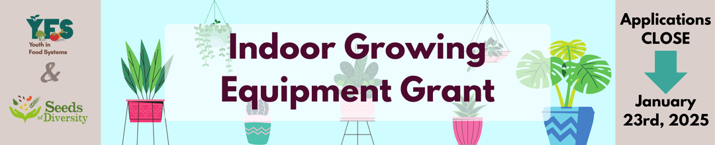[Youth in Food Systems (YFS)](http://www.youthinfoodsystems.ca) is a program of [Seeds of Diversity Canada](http://www.seeds.ca). Since 2017, we have been supporting school based food production and youth engagement in food literacy and leadership in Waterloo Region.

Thanks to a generous donor, we are offering a total of 5 indoor hydroponic growing systems and 21 seed starting setups (15 small and 6 large) to schools in Waterloo Region, intended to catalyze and elevate food production on school grounds and within communities.

Schools are able to apply for one indoor growing system AND/OR one of either a one-shelf seed starting setup OR a three-tiered seed starting setup.

[More details about each of the above are available here](https://seeds.ca/schoolfoodgardens/wp-content/uploads/2025/01/Indoor-Growing-Equipment-Grant-Setups.pdf)

**Who is eligible to apply?** Any school (K-12) in Waterloo Region currently growing food in their school community or interested in growing food in their school community (e.g. new food gardens, expanding garden programs to include food, renewing lapsed or inactive programs, to supply food for school lunch programs, etc). Priority will be given to sites currently within our [School Garden Network](https://seeds.ca/schoolfoodgardens/find-a-garden/). Successful applications must demonstrate the following (see application form for more details):

* Support from school administration
* Staff engagement (minimum 2 educators, and ideally at least one additional staff member)
* A strategy for student engagement
* Plans for care during school breaks (e.g. March Break, winter holidays, summer break)

In reviewing applications, we will give consideration to social factors impacting a healthy school environment, and the potential impact of an indoor growing system and/or seed starting setup for your school. The more you can tell us about your school and the potential impact of these tools, the better.

**Interested schools should submit their completed application as a .docx or .pdf to** [**info@youthinfoodsystems.ca**](mailto:info@youthinfoodsystems.ca)**. If you have questions or are in need of assistance, contact Andrew at** [**info@youthinfoodsystems.ca**](mailto:info@youthinfoodsystems.ca)

DEADLINE for applications: Thursday, January 23rd, 2025 at 11:59pm EST.

**Our intention is to support you in the initiation and use of these tools. Selected schools will receive the following:**

* Your materials purchased and arrangements made for pickup/delivery
* Online resources for initiating and maintaining your indoor growing tools
* Educators Conference on March 1, 2025 with in-person resources and support for school based food production
* Annual seeds and other inputs necessary for the sustainability of the tools, as resources allow

**Selected school sites will be responsible for the following:**

* Arranging for at least one school representative to attend the Educators Conference on Saturday, March 1st 2025 [RSVP by February 16th](https://forms.gle/h1HeEUqC1W9EHgob6)
* Working with YFS staff to coordinate pickup/delivery of the tools in February
* Developing a plan for school and youth engagement in the garden
* Becoming a member of the School Garden Network community, if not already
* Working with YFS staff to share stories, updates, photos (as allowable), and other information about the use and impact of the indoor growing tools on an occasional basis (e.g. touchpoints 2-3 times/year)

DEADLINE for applications: Thursday, January 23rd, 2025 at 11:59pm EST.

[Please also RSVP for the Educators Conference by February 16th](https://forms.gle/h1HeEUqC1W9EHgob6)

**General Application Questions**

**Name and address of school**:

Add text here.

**Name and role of contact person:**

Add text here.

**Contact information**

(Phone): Add text here.

(Email): Add text here.

**Municipality associated with this funding request** (school location):

Add text here.

**Highlight which indoor growing tools are you applying for**:

1. Indoor Growing System and/or *(Complete Page 4 & 5)*
2. One Shelf Seed Starting Setup or *(Complete Page 6)*
3. Three-Tiered Seed Starting Setup *(Complete Page 6)*

**Indoor Hydroponic Growing System** **Questions   
(Skip to Page 6 if not applying)**

1. Please describe how staff, including both the school administration and educators will be engaged with the system. Please list at least two key champions, their roles and contact information (e.g. educators, principals, administrators, custodians) and how they will be be involved in using the indoor growing system:

Add text here.

1. Tell us about who will use the indoor growing system and how. For example, will specific classes be using it? How will it be incorporated into the curriculum? Will student clubs use the system? If community members have access, how will they use it for food production?

Add text here.

1. How will students be engaged in using the system for food production, during 2025 and beyond:

Add text here.

1. Describe your plan for summer and school break maintenance and longer-term sustainability. Do adult allies and students have a history of staying engaged during school breaks? Do you have existing relationships/partnerships with community groups who could use the indoor system when not in use by the school?

Add text here.

1. Describe any social factors impacting the school environment that the indoor growing system might address (eg. accessibility, newcomer engagement, inclusivity and safe space, income barriers, special education needs, etc.):

Add text here.

1. Finally, please tell us what impact you think an indoor growing system could have on your school, its students, staff, or community.

Add text here.

**Seed Starting Setup Questions**

1. Please list two or more key champions, their roles and contact information:

Add text here.

1. Tell us about who will use the setup and how. For example, will specific classes be using it to grow seedlings? How will it be incorporated into learning activities? Will student clubs use it?

Add text here.

1. Describe your plan for use of the seed starting setup. Will it be used to grow seedlings for your school’s garden? Will it be a source of fundraising (e.g. seedling sales)? Shared within the larger community? Outline the overall purpose and need for the setup.

Add text here.

1. Describe any social factors impacting the school environment that a seed starting setup might address (eg. accessibility, newcomer engagement, inclusivity and safe space, income barriers, special education needs, etc.):

Add text here.

1. (If applying for a three-tiered system) Please tell us why your school community would be better served by a three-tiered system vs a one shelf system? Ie. Why do you need that extra capacity in order to carry out your plans?

Add text here.